K2003 Jeopardy内容

【Language Arts】

**10 points**

What sound does letter F make?

**F makes the sound /f/.**

**20 points**

What’s this sign?



**It’s a stop sign.**

**30 points**

1. Can you speak out a word that begins with the sound /a/?

**Apple, ant, ax, astronaut begins with the sound /a/.**

1. Can you try to read these words?

**fat mad Tom sat fan Sam**

**40 points**

This is a shopping list. Can you read it?

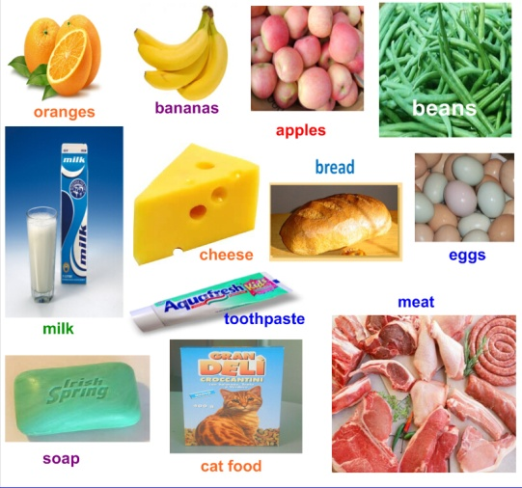

【Math】

**10 points**

What’s this number? 20

**It’s number twenty.**

**20 points**

How many chips show eleven lollipops?

**Eleven chips show eleven lollipops.**

**30 points**

There are 8 students reading books, 10 students doing homework, how many students are there all together?

**There are 18 students all together, because**

**8+10=18.**

**40 points**

Where is the cat?

Can you describe it with prepositions of location?

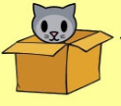 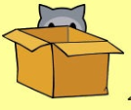 

**The cat is in the box.**

**The cat is behind the box.**

**The cat is in front of the box.**

【Science】

**10 points**

What’s this?

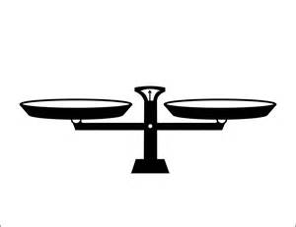

**It’s a balance.**

**20 points**

1. Can you speak out a living thing?
2. Can you speak out a non-living thing?

**Living things: animals, plants, human…**

**Non-living things: school supplies, air, water, …**

**30 points**

What are five senses? Please fill a word on the blank.

**You see things with your ____.**

**You smell things with your ____.**

**You taste food with your ____.**

**You hear sounds with your _____.**

**You touch things with your _____ and skin.**

**40 points**

1. What do animals need? (four things)
2. What do plants need? (five things)

**Animal need: food, water, air, shelter.**

**Plants need: water, air, sunlight, soil, space.**

【Reading】

**10 points**

**Can you read these sentences?**

This is my mom. My mom likes to dig.

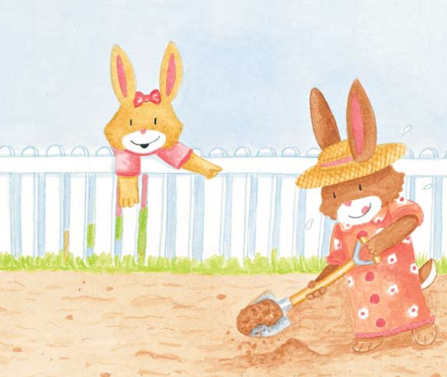

**20 points**

**Can you read these sentences?**

** **

Sam can tap. Sam can nap.

**30 points**

**Can you read these sentences?**

At the zoo.

We can see a monkey.

We can see a bear.

We can see an elephant.

We can see a zebra.

We can see a bird.

**40 points**

**Can you read this book?**

The mat

Go to the mat, Pat.

Go to the mat, Sam.

Go to the mat, Nat.

Go to the mat, Jim.

Pam can not fit.

Where can Pam sit?

Pam can sit here.

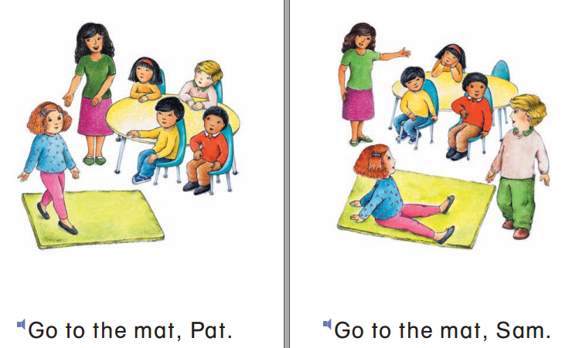

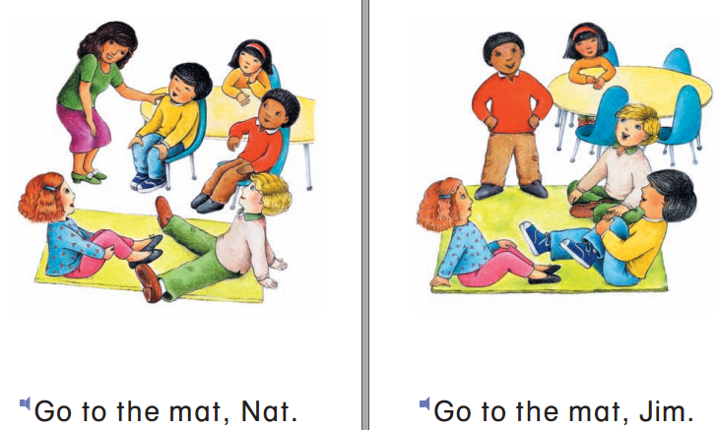

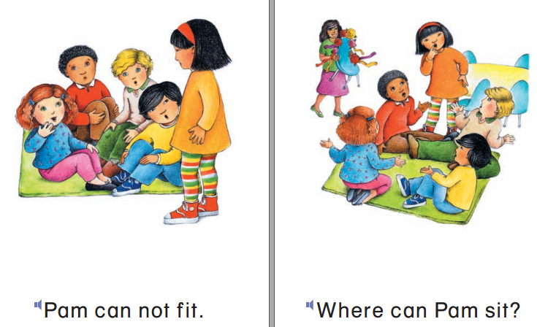

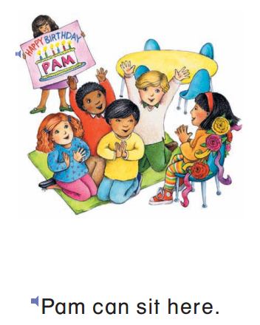

K2002 Jeopardy内容

【Language Arts】

**10 points**

What sound does letter G make?

**G makes the sound /g/, which is a hard sound.**

**20 points**

What’s this sign?

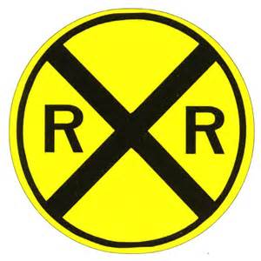

**It’s a railroad sign.**

**30 points**

Can you try to read these words?

**Pizza jellybeans lox kiwi yogurt ziti**

**40 points**

Can you tell me something about about an iguana?

**Iguana hatch from eggs.**

**Iguana eat plants.**

**Iguana sleep in the sun.**

**Iguana have long tails.**

【Math】

**10 points**

What’s this number? 57

**It’s number** **fifty-seven.**

**20 points**

How many chips show eleven lollipops?

**Eleven chips show eleven lollipops.**

**30 points**

Can you read these number sentences?

7 - 1 = ? 7+1=?

**One fewer than seven is six.**

**One more than seven is eight.**

**40 points**

There are 8 students reading books, 10 students doing homework, how many students are there all together?

**There are 18 students all together, because**

**8+10=18.**

【Science】

**10 points**

What’s this?

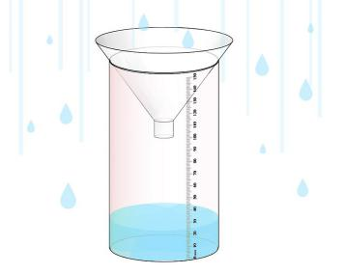

**It’s a rain gauge.**

**20 points**

How many states of matter? What are they?

**Three. Solid, liquid, gas.**

**30 points**

Could you speak out at least three kinds of bodies of water?

**Ocean, river, lake, stream, pond.**

**40 points**

1.Can you speak out an animal that is covered with shells?

2. Can you speak out an animal that is covered with feather?

3. Can you speak out an animal that is covered with scale?

**Animal covered with**

**shells: Crabs, snails, turtles…**

**feathers: eagle, bird, flamingo,**

**peacock, …**

**scales: fish, snake, turtles,**

**crocodile/alligator, …**

【Reading】

**10 points**

**Can you read these sentences?**

This is my mom. My mom likes to dig.



**20 points**

**Can you read these sentences?**

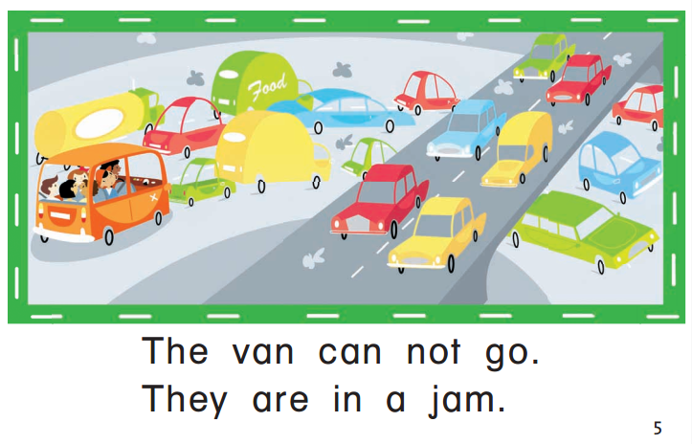

**30 points**

**Can you read these sentences?**

What is very long?

This is a giraffe.

The giraffe has a very long neck.

Here is a frog.

The frog has very long legs.

This is a bird.

The bird has a very long beak.

**40 points**

**Can you read this book?**

Going on Vacation

We put the bags in the car.

We put the toys in the car.

We put the blankets in the car.

We put the balls in the car.

We put the bears in the car.

We put the food in the car.

We put the dogs in the car.

Goodbye!